

**DONEWIT**

**SUBMITTED TO**

**DEPARTMENT OF COMPUTER SCIENCE**

**SEMSTER 7TH**

**JULY-DEC 2020**

**UNDER THE SUPERVISION OF**

**RIDHIMA RANI**

**SUBMITTED BY**

RACHIT KAPOORPUNIT PUNDIRPULKIT GUPTA

171099161417109916131710991610

**CHITKARA UNIVERSITY**

**CHANDIGARH-PATIALA NATIONAL HIGHWAY, RAJPURA, DISTT. PATIALA**

**PUNJAB, INDIA**

**DECLERATION**

I hereby declare that the project work titled, “DoneWIt” submitted as part of Bachelor’s degree in CSE, at Chitkara University, Punjab is an authentic record of my work carried out under the supervision of Ridhima Rani.

**Place**:

**Verified by:**

**Date:** ___December, 2020

**Group Members Name:**

Rachit Kapoor

Punit Pundir

Pulkit Gupta

**Signature of Supervisor**

**Signatures:**

**ACKNOWLEDGEMENT**

The success and final outcome of this project required a lot of guidance and assistance from many people and we are extremely privileged to have got this all along the completion of our project. All that we have done is only due to such supervision and assistance and we would not forget to thank them.

I respect and thank **Ms. Ridhima Rani**, for providing us an opportunity to do the project work, giving us all support and guidance which made us complete the project duly. We are extremely thankful to her for providing such a nice support and guidance

We are thankful to and fortunate enough to get constant encouragement, support and guidance from all Teaching staffs of Computer Science which helped us in successfully completing our project work.

**___December, 2020 Rachit Kapoor Punit Pundir**

**Pulkit Gupta**

**CONTENTS**

**TITLE PAGE NO.**

* Declaration
* Acknowledgment

1. Introduction 1
2. Literature Survey 2
3. Requirements 3
4. Work Done 4-8
5. Conclusion and Future Scope 9
6. References 10

**INTRODUCTION**

**DoneWIt** is an initiative to create an easy platform for everyone to sell and buy things.

Do you have band instruments, electronics, jewellery, or other items lying around your house that you no longer use or need? Install our app today.

**LITERATURE SURVEY**

Before beginning with this app we went through many articles on the internet and found a lot of reasons why we should proceed with making this app.

Below are the 3 main benefits of buying and selling used items.

1. The Environment

Buying a used product means that no new resources or energy are required to make that product. This reduces your carbon footprint and is extremely beneficial to the environment. Selling your used items also prevents pollution. Rather than throwing your no longer used item away, you are giving it a new life. Go green and buy used and sell items that you aren't using anymore!

2. Saves/Earns You Money

Selling items you no longer use or need is a great way to get some extra cash that you normally wouldn't have. Buying used items also saves you a lot of money, as used items are normally at least 50% lower than the original price. Your wallet will thank you later!

3. Helps Others

Selling items you no longer need also gives others an opportunity to purchase something they may not have been able to afford at full price. Why throw something away when you can give someone else the ability to have that item at a great price? Buying and selling used also helps your local economy and small businesses, instead of spending your money at large corporations.

So after conducting this online survey we have decided that there is a need of an app for selling and buying used items in this fast paced world.

**REQUIREMENTS**

**Hardware Requirements**

PC, Android or an ios device is required to run this app. Following table shows the hardware specifications needed for each device.

|  |  |  |  |
| --- | --- | --- | --- |
| **Requirement** | **PC** | **Android** | **ios** |
| **RAM** | 2 GB or above | 4 GB or above | 4 GB or above |
| **Screen Resolution** | 1366x768 | 720x1280 | 720x1280 |
| **Processor** | 1 GHz or above | 1.5 GHz or above | 1.2 GHz or above |
| **CPU Cores** | 2 or above | 2 or above | 2 or above |
| **Touchscreen** | No | Yes | Yes |

**Software Requirements**

Following table lists the software requirements needed for each device.

|  |  |  |  |
| --- | --- | --- | --- |
| **Requirement** | **PC** | **Android** | **ios** |
| **Operating System** | Windows7/Linux | Android v5 or above | Ios v7 or above |
| **Browser** | Microsoft Edge etc. | Google Chrome etc. | Safari etc. |

**Skill Requirements**

* Basics of installing any application and navigating through it.
* Basics knowledge of using browser and operating system in case of PC.

**WORK DONE**

**App Design & Pages**

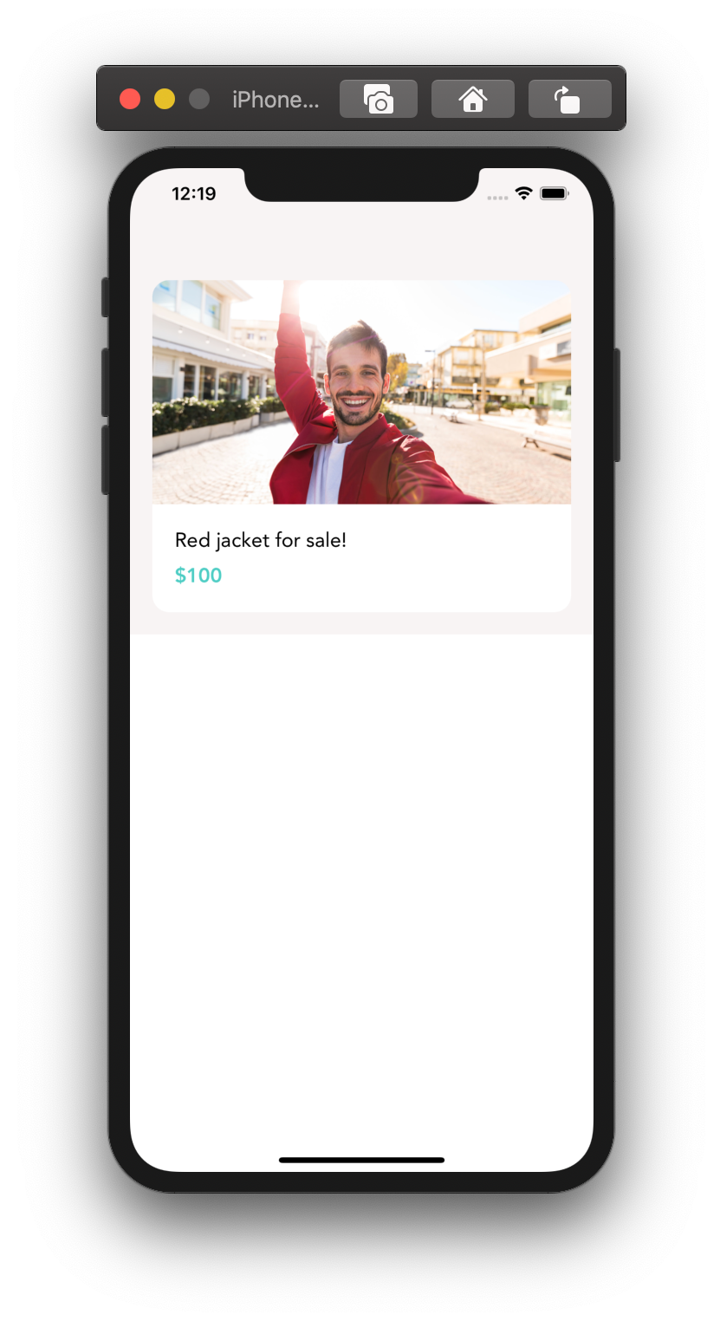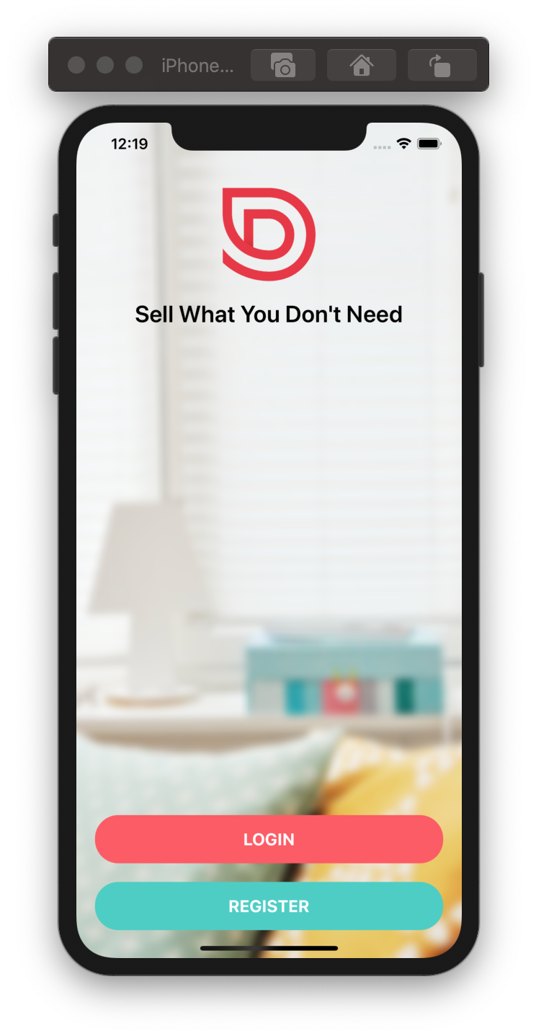

CARD COMPONENT

WELCOME SCREEN

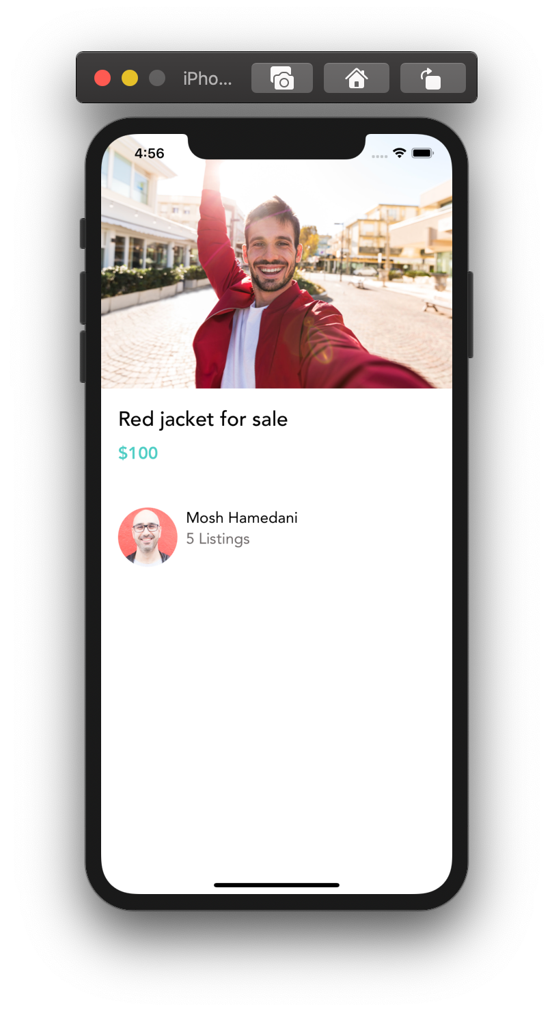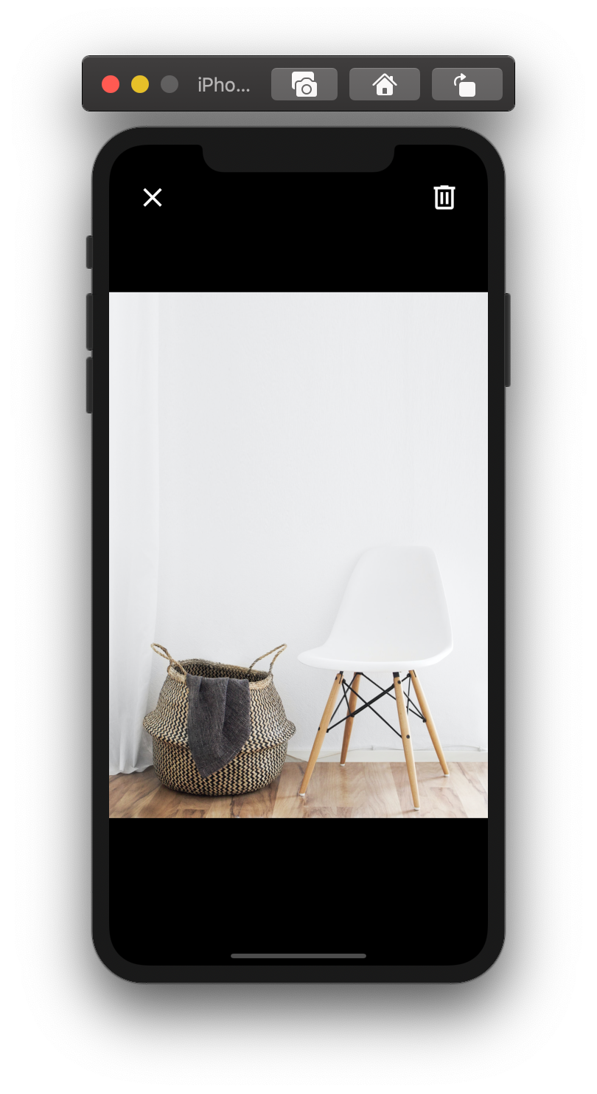

VIEW IMAGE SCREEN

LISTING DETAILS SCREEN

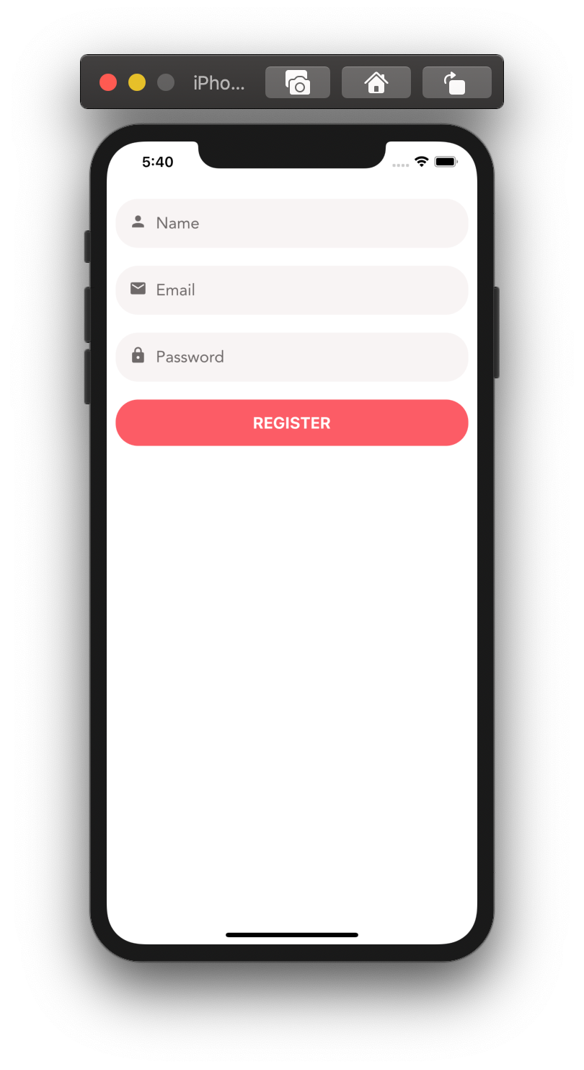

Form

Register Screen

* A screen for registering a new user. This screen is very similar to the login screen

Listing Edit Screen

Here’s the screen for posting a new listing.

Validation rules:

* Title: A required string, minimum one character long
* Price: A number between 1 and 10,000
* Category: A required but nullable object

# 

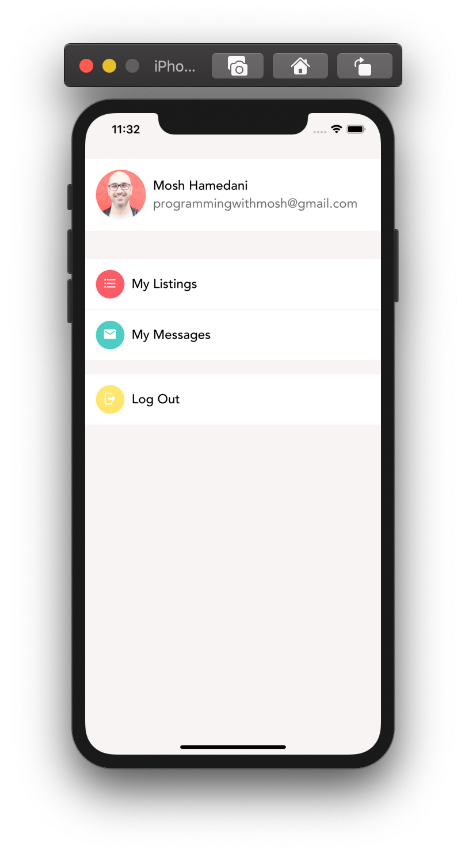

Lists

My Account Screen

This is where the user can view their listings, messages, etc.

For the icons, we used **Material Community Icons set.**

* My Listings: format-list-bulleted
* My Messages: email
* Log Out: logout
* Colour Scheme:
* My Listings: primary
* My Messages: secondary
* Log Out: #ffe66d

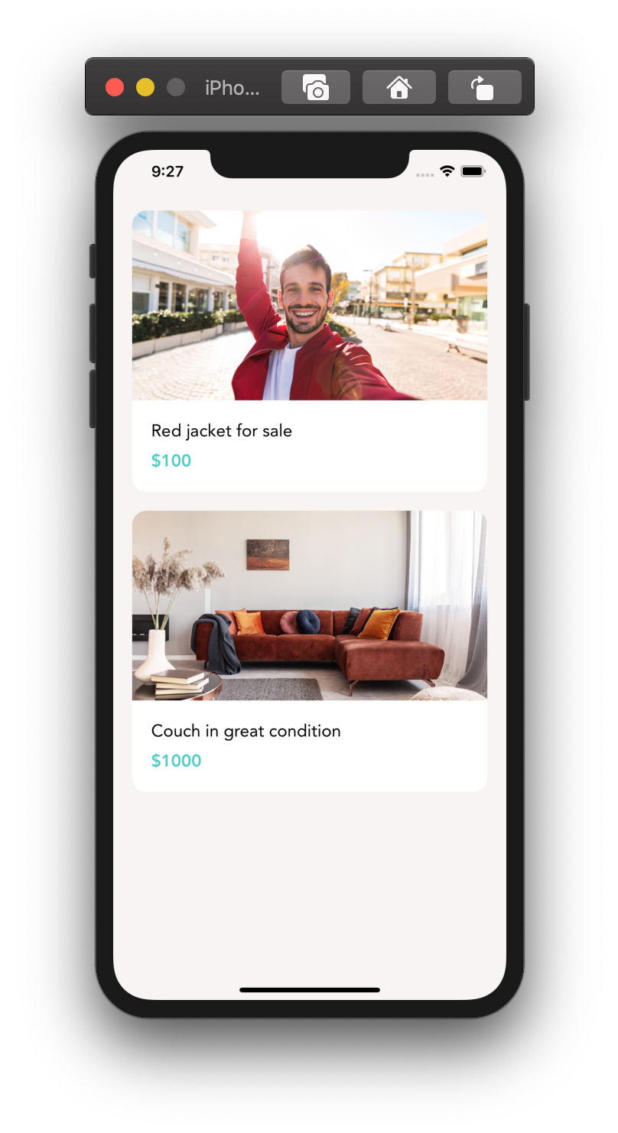

Listings Screen

Here’s the main page of our app that the user will see once they log in

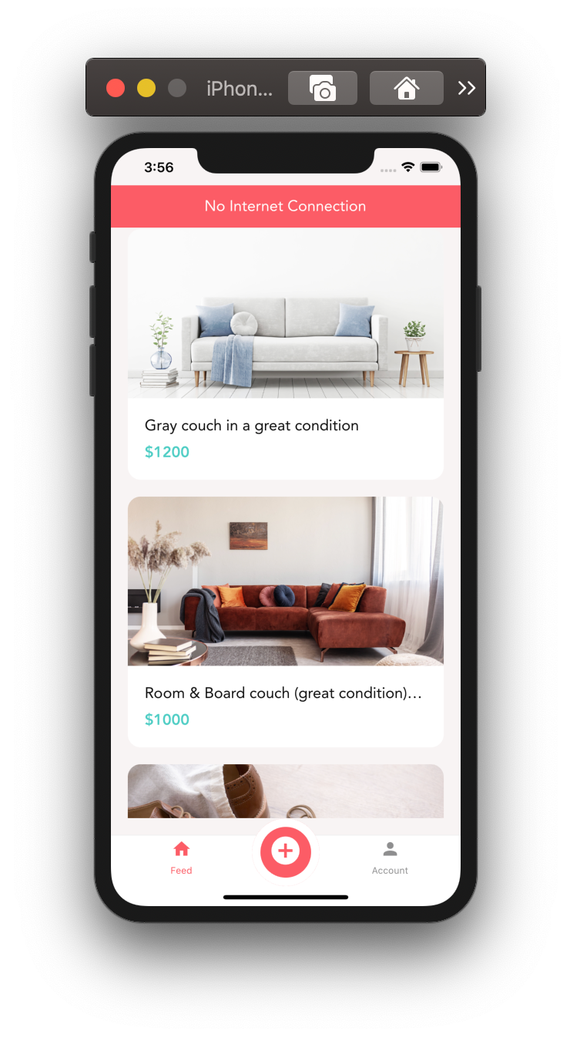

Offline Notice Bar

When offline an offline notice on the top will appear.

Saving the Listing

When the user submits the listing form, send the listing to the server and show a progress bar. When the upload is complete, show an animation and reset the form.

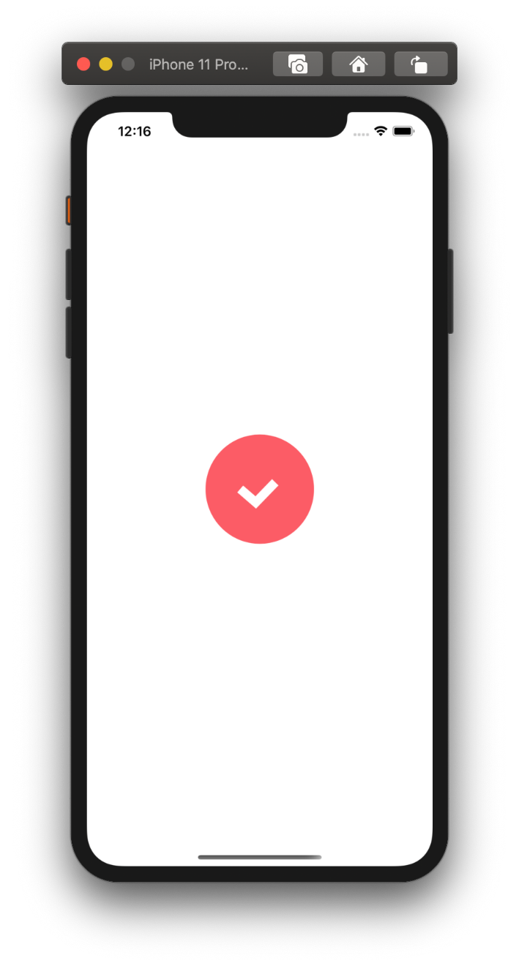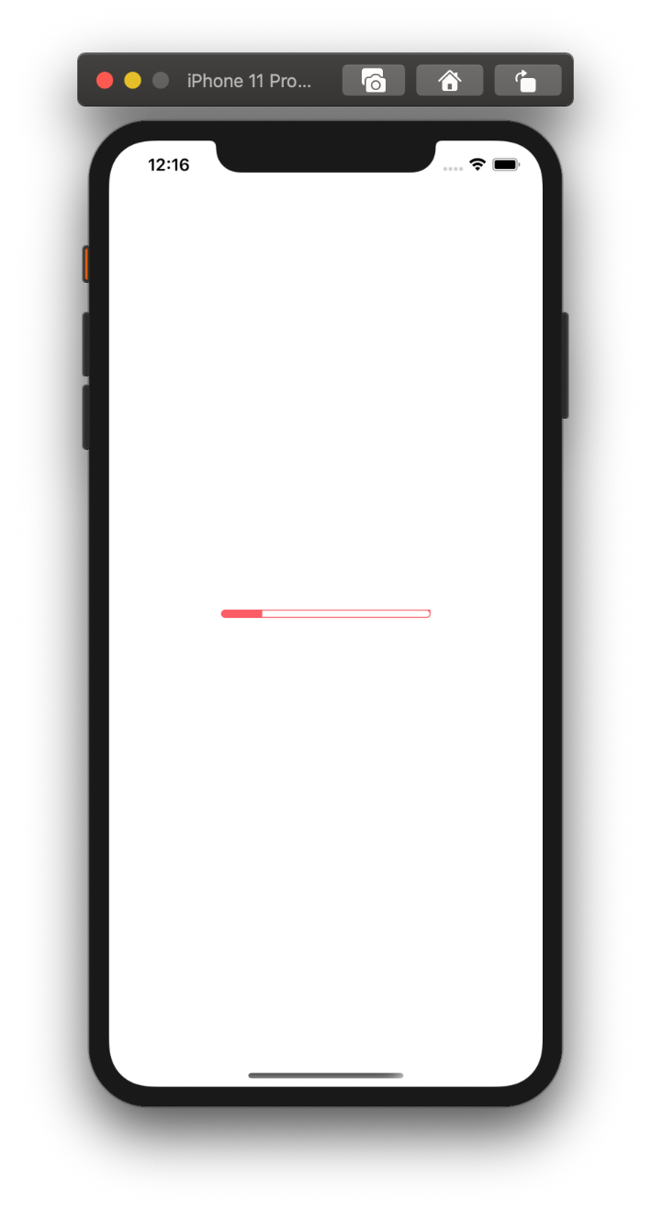

**CONCLUSION AND FUTURE SCOPE**

**Conclusion**

With this project we have brought our idea to life i.e. to create a platform where users can sell and buy the items they no longer need in their life. By making an app with the help of technologies like react-native, expo, nodejs and many more we have made sure that we use the best and the latest technologies out there.

We are proud to say that we have created an app which meets all our expectations and fulfils aforementioned requirements. Not only that, but with this app you get a smooth and a simple solution to clear your home of the things that you don’t need which can turn out to be extremely useful for the other person.

**Future Scope**

Next stop for this project is to get this deployed on Web, Android and IOS so that everyone can start using our app. Some features like bidding, wish list, catalogues etc. are in the design phase and will move to production based on the response we receive from our users.

Also with the increase of users and data we will need to increase our database and server capacity. Moving the project to cloud services like Azure & AWS is one the best solution for scalability.

So all in all there are a lot of things that can be done. This is just the starting point of a long journey and we are looking forward to rolling out new features and improving the overall experience of the app.

**REFERENCES**

1. <https://codewithmosh.com/p/the-ultimate-react-native-course>
2. <https://reactnative.dev/>